ME 424 Engineering Design VIII

Phase 4 – Refining Design and Prototyping

**3D Printed Granular Jamming Hand**

**A Senior Report**

**Group #9:**

Melissa Indoe

Chris Kang

Sean Phelan

Maggie Serra

Chris Wallace

**Advisors:**

Robert Chang

Jennifer Field

**STEVENS INSTITUTE OF TECHNOLOGY**

Castle Point On Hudson

Hoboken NJ 07030

(February 2014)

**3D Printed Granular Jamming Hand**

# Abstract

An open-source and primarily 3-D printable hand prosthesis is to be developed by a team of five Mechanical Engineering seniors in a student-driven design project. The hand will allow for performance of relatively low strength, high dexterity, everyday tasks. To meet this goal, the hand prosthesis will combine the technologies of existing 3-D printed hands with the use of granular jamming to maintain a firm grip at a fraction of the cost of existing prostheses. Conceptual designs have been generated and finalized. Components have been ordered and a prototype has been fabricated. Further designs for additional components are being finalized and plans for future testing and development have been generated.

**Authors:** Melissa Indoe, Chris Kang, Sean Phelan, Maggie Serra, and Chris Wallace

**Advisors:** Robert Chang and Jennifer Field

**Department:** The Department of Mechanical Engineering

Contents

Abstract 2

Introduction 3

Project Objective 3

Semester Goals 3

Deliverables 3

Overall Design/Engineering Analysis 4

SolidWorks Model 4

Joint pin analysis 4

Granular Jamming 7

Finger Control 8

Physical Model 9

Base Finger Design Modifications 10

Palm Design Modifications 10

Overall Hand Design Modifications 11

Prototype Fabrication Plan and Cost 12

Performance Testing 13

Comments from Phase 3 14

Gantt Chart 15

# Introduction

## Project Objective

The project objective is to create an open-source, high-functioning, affordable, prosthetic hand. The prosthesis will be task oriented and able to perform simple activities requiring low strength and high dexterity. The hand should be of similar size and weight of an average human hand and look as human as possible. The prosthesis is designed for a patient who has lost an arm below the elbow. In addition to designing a fabricating a hand, the modifications will be made for an existing forearm housing to hold the electronics and components for the prosthetic. By use of open-source software, inexpensive materials and parts, and simple assembly, this design will allow other users to take the prosthetic and make whatever modifications they desire, whether for control, or aesthetics. Several major issues in this project include maintaining dexterity of the fingers, device durability, and keeping the device affordable and the parts easily attainable.

There are several goals for the prosthetic hand. It will be able to pick up, hold, and put down objects of various sizes and shapes. It will also open and close different sized doors, from knobs to refrigerators. The prosthesis will be able to make simple hand gestures, including “thumbs up” and pointing, and will also be able to use a computer mouse. While the hand may not be complex enough for the use of traditional utensils, it will be able to hold occupational therapy tools, including cutlery and writing utensils. If the prosthesis can complete most of these tasks, the project will be a success and can prove very useful in day-to-day life.

## Semester Goals

There are a few goals for this semester. The primary goal is to have a finished model of the prosthesis and have a fabricated a working prototype. A second goal is to finish and update a website documenting the progression of the project and downloadable models files and code.

## Deliverables

This semester will involve many tasks to complete the remaining phases of our project. Several deadlines have been put forth by the professor, and the group has created its own deliverables in order to achieve these deadlines. This semester will contain Phases 4, 5, and 6 of our project. The deadlines provided to us are shown below:

|  |  |  |
| --- | --- | --- |
|  | **Written Report** | **Oral Report** |
| **Phase 4** | February 10 | February 13 |
| **Phase 5** | No Written Report | March 18 |
| **Phase 6** | May 6 | May 8 |

During Phase 4 the group has ordered parts, 3D printed the most current iteration of the finger and the first complete hand, started programming for the Arduino Uno, started editing the forearm model, is developing methods for granular jamming production and is continuing to develop the project website. In Phase 5, the team will test and iterate the hand as well as the granular jamming system. Programming the Arduino will be mostly completed except for necessary modifications as testing continues. As parts are delivered, they will begin to be assembled. The website will be completed by the end of Phase 5, as required by the professor. In Phase 6, the final testing will be completed and a final prosthesis will be created. A poster will be constructed for Senior Design Day being held on April 30, 2014. A final presentation will be given on May 13, 2014.

# Overall Design/Engineering Analysis

The 3D printed granular jamming prosthetic hand has several components that are essential for finger movements, granular jamming and force transfer from motors to fingers. The hand will be printed as a whole and forearm case will be printed as soon as the team comes up with CAD model that can contain motors, wires, vacuum, and Arduino.

## SolidWorks Model

**IS THIS SUPPOSED TO BE EMPTY?**

## Joint Pin Analysis

**WE HAVE NEW JOINT PINS. IS THIS UP TO DATE?**

The team finally decided not to use pins to hold the hand together because the there are no forces that would break the plastic connections that work as pins. The other reason that the team decided not to use pins is because the hand can be printed as a whole. The prototype hand is printed and ready for testing with Arduino.

The force analysis was first run on the fingertip, with force applied at the bar where the driving cable would be tied. Force was defined as 4.5 Newtons, the maximum torque of the selected servo motor. The joint pins were defined as fixed geometry since pulling the wire inward would grind the joint pins against the joint pin holes of the next segment.

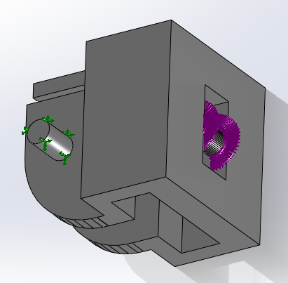

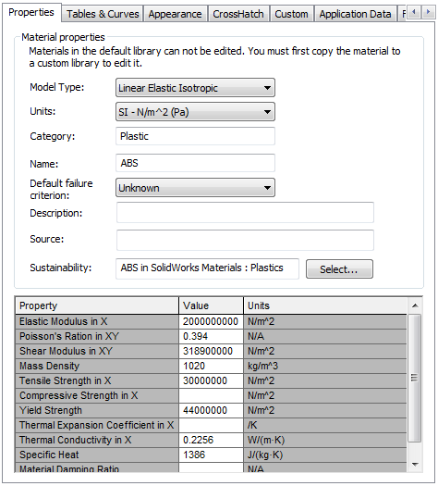

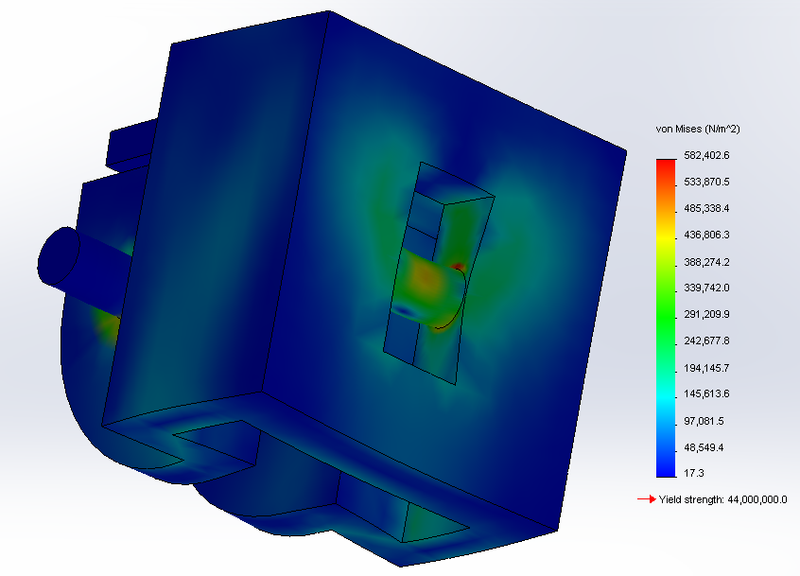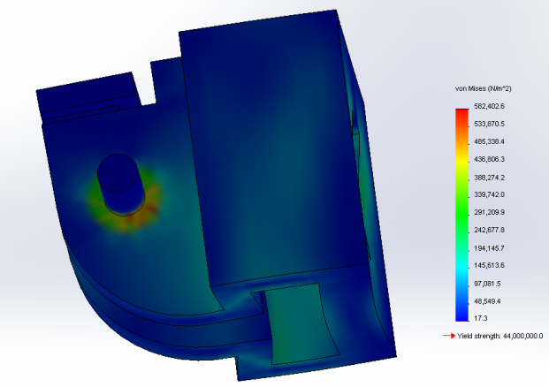Running the analysis showed that ABS passed the standard working condition requirements with flying colors. Maximum stress in the segment was found to be 0.58 MPa, concentrated around the base of the joint pins (as expected). “Failure” was defined as reaching the yield strength of ABS plastic (44 MPa) since any force large enough to cause plastic deformation of the pins would prevent them from rolling properly in their joints. This yielded a factor of safety of 75.5 for the fingertip segment.

This analysis was then repeated for the middle and base finger segments. For these segments the force application was along the bottom and back of the joint holes and along the front and top of the wire guide. The joint pins were again defined as fixed points. The force was defined as 4.5 Newtons, spread evenly over points of contact.

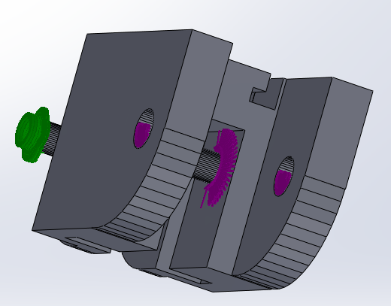

Maximum stress was found to be 7.5 MPa for the middle segment and 13.8 MPa for the base. This yielded an overall factor of safety of 3.2, more than reasonable (especially when considering that the force will probably be more distributed when the hand is actually used—the simulation assumes that motor force is applied equally to each finger segment and that each segment receives maximum possible force).

Since the joint pin analysis showed that ABS passed use cases, the idea of printing in polycarbonate plastic could be eliminated, since the extra strength would not be necessary for the scope of the project. This eliminates a great deal of cost and complexity. Additionally, since ABS proved more than adequate, PLA (a weaker plastic) was also tested (PLA is more environmentally friendly than ABS, since it is made entirely from plant material, and releases no toxic fumes while printing).

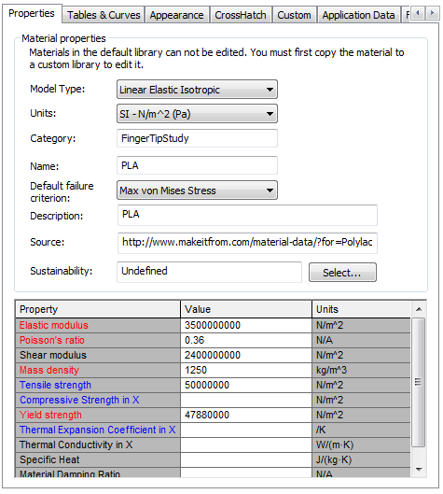

## Granular Jamming

The 3D printed granular jamming prosthetic hand includes granular jamming technology. The concept of granular jamming is that small particles in a flexible container become rigid when they are tightly packed together. Granular jamming application makes the hand capable of picking up relatively small objects. Picking up objects is done by pressing a pad on the object, jamming the granules by using a vacuum to remove air from the pad, and then lifting the object with the pad.

To model the granular jamming pad, the team needed specifics on the operations of the granular jamming system. Based on the article “Universal Robotic Gripper Based on the Jamming of Granular Material” by Browna et al., a change of pressure of 75 kPa is sufficient to pick up objects. The team sourced a pump with this pressure differential. Using this, the team found the diameter size tubing that would be needed to hold up an object. The following shows the details.

*Force on object*

Assuming object to be held is 1 lb (0.453 kg)

ΔP= 75kPa

F=P*A

0.453kg=75000Pa*(πr2)

Diameter=8.7mm - 10mm standard tubing will be used.

Next the team wanted to make sure that the amount of time it takes to remove air from the pad would not be too long, so we calculated evacuation time using specifications from the pump chosen.

*Evacuation time*

q = 3.659*10-5 m3/s

V = 3.659*10-5 m3

P0 =1013.25 mbar

P1 = 266.25 mbar

t = V/q * ln (P0/P1)

t = 0.652 seconds

Both calculations resulted in reasonable outcomes.

Pump will be controlled by either manually. Starting and stopping the granular jamming pad on its own whenever the patients want it to grab something with the pad and let the object go will complicate our design and result in battery drainage. To reduce complexity of the design, manually turning on and off granular jamming pad will benefit not only battery duration but also exact time for grabbing and letting the object go. Switch will be attached to the forearm and connected to Arduino.

## Finger Control

The tips of the fingers are attached to strings that are controlled by servo motors. The amount of torque motors generate will depend on how much pressure is applied to the fingers. Sensors used are the Hall Effect sensors. The principal behind the sensors are quite simple. As the finger contacts an object, that object will resist the finger’s closing. As a result the cable will begin to offer more resistance to getting reeled in by the motor. If the motor is free to slide, it begins to pull itself forward, toward the hand. By mounting the motor with a spring in the front, it will be pushed to the back of its housing when in a neutral state, but when the finger contacts an object, the motor will pull itself forward, compressing the spring. The more force exerted at the finger, the more the motor will pull forward. By placing a sensor at the back of the motor housing (consisting of a magnet attached to the motor via a small piece screwed to the motor wings, and a Hall Effect sensor at a stationary point of the forearm), distance that the motor has been pulled forward can be sensed via the change in measured magnetic field (measurements will be higher at a neutral state, and drop when the finger is pressing into an object). This means that pressure can be reasonably measured, accurately and inexpensively, while having absolutely no electronic components in the hand itself.

When the signals are read or the distance of magnet is far enough, the motor will generate torque and make the hand curl in.

Physical Model

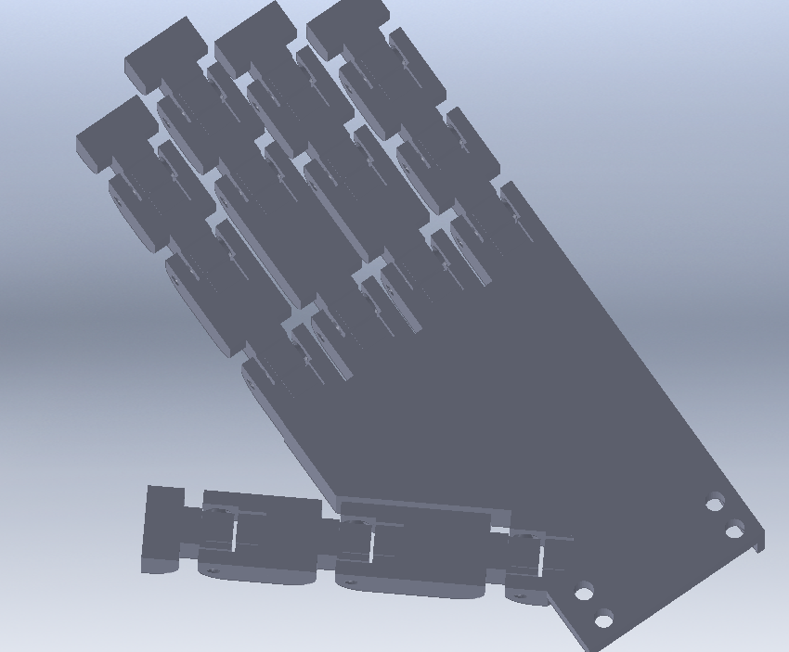

## Base Finger Design Modifications

A fully functional base finger design was completed by the end of phase 3. However, since then, several modifications were added to the design in order to make the finger even easier to print and cable. The changes included redesigned and repositioned wire guides, conical joint pins, reduced height, and smaller tolerances.

The wire guides were redesigned because although the previous design functioned well, it featured relatively large overhangs where the current wire guides, round pins, bridged across the center of the finger. The new design has fewer guides (since some of the existing guides turned out to be unnecessary), and the guides are now flat faces with a hole for wire. This design eliminates overhangs, since the hole is round and therefore graduates up to the bridge in the center. The guides were also made thinner and moved downward, which increased the finger’s range of motion (since before there was a small amount of friction within the joints).

The joint pins were changed from a cylindrical to a conical design for the same reasons as the change in cable guides. By starting the pins large and tapering them to become smaller, the printer goes from making a large overhang in one pass, which is very prone to drooping down and bridging to the joint hole, to making a lot of small overhangs, each stacked on top of the other, in a graduation. This is far less prone to bridging, and, as long as the angle is kept under 45 degrees will actually not deform in a standard hobbyist 3D printer.

Height of the fingers was also reduced by 4mm to make them slightly less blocky and more realistic. Previously they had been a little too tall and blocky. Finally, the tolerances between joints were significantly lowered. This was because the joints in the previous base finger were fairly loose and one of the TAs suggested lowering the tolerance to a standard accepted level for printed revolute joints (.02 inches) to decrease this looseness.

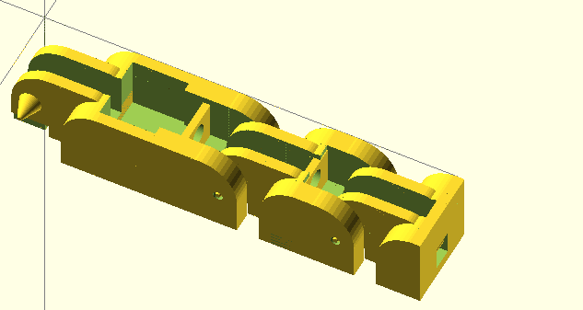

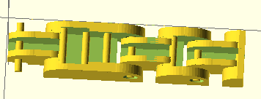

## Palm Design Modifications

Figure 1: Previous finger iteration (left) with pin-shaped cable guides, round joint pins, and large tolerances, and new finger iteration (right) with redesigned cable guides, conical pins, and lower tolerance.

At the end of Phase 3, a palm design had been completed with 4 low-level cable guides running along the palm, toward the wrist. This palm design also had no guard to keep the granular jamming pad from interfering with the thumb. It also did not have a mounting point for the forearm, and was rather thick. What was thick?

The palm was therefore heavily modified during Phase 4. These changes include taller and more complete cable guides, a mounting point for the forearm, a guard for the thumb, and thinner sides. The fingers were also moved further apart, to prevent bridging, and the thumb was moved away from the side of the palm for the same reason.

These new, taller, cable guides were very important since the original cable guides were very low to the palm surface. This positioning forced the cables downward and decreased their leverage on the fingers, taking more energy to curl the hand inward—or worse, possibly creating a toggle point and stopping motion before the finger is fully bent. OpenSCAD does not support a sweep or loft feature, so small gaps were left in between these cable guides where their direction was changed. This is however not an issue because the granular jamming pad is not so fluid that it will fill in these small gaps.

The forearm mounting point just consisted of a flat plate with holes for four plastic screws. The holes are slightly larger than screw diameter, making it possible to drop them through the palm wrist attachment and thread into the forearm, ensuring a tight fit with no gaps.

The thumb guard exists so that the granular jamming pad cannot spill over the side of the palm and create friction against the side of the thumb. This ensures a good range of motion for the thumb and prevents unnecessary wear on the granular jamming pad.

Finally, the fingers and thumb were spaced out more to prevent the plastic from bridging between fingers or between thumb and palm and impeding motion. The final palm design was as follows:

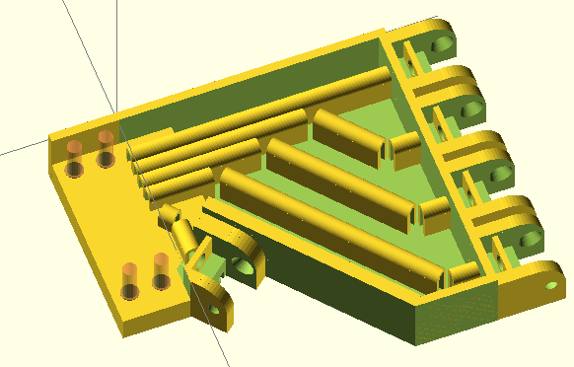 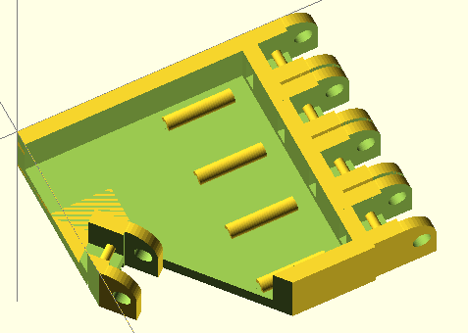

Figure 2: Previous palm iteration (left) with low level cable guides, no forearm mount, and no thumb guard. Current palm iteration (right) with and more complete cable guides, a forearm mount, and a thumb guard.

## Overall Hand Design Modifications

At the conclusion of Phase 3, a hand design had been completed with all equally sized fingers. For Phase 4, finger length was adjusted to more closely match the proportions of human fingers. Every finger (with the exception of the pinky) is exactly the length of the average human equivalent. The pinky is about 10cm longer than average due to the hinge design. This is because if the finger were any shorter the hinges would overlap and the finger would be unable to bend.

# 

# Prototype Fabrication Plan and Cost

Figure 3: Previous (left) and current (right) hand iterations. Current hand iteration includes updated palm, updated base finger design, and realistic finger lengths.

The first complete hand prototype was printed on Thursday, February 6th. All of the 3D printed parts will be produced using the 3D printing facilities at Carnegie lab. The majority of the non-printable parts have already been ordered. Cost thus far has been does Sean know how much we’ve spent so far?, well within budget, with the ordered parts coming at their budget, and the hand itself using 150 cm3 of ABS plastic, costing about $7.05 in material.

Future plans for fabrication include slightly modifying the hand design and printing the final iteration (which should occur within the next 1-2 weeks), then finalizing and printing the forearm design (scheduled for completion within about a month) and then finally assembling the parts and writing some basic programs for grips, etc.

The granular jamming pad has been designed and production of the pad will begin within the next 1-2 weeks. The current plan for granular jamming pad production is to 3D print a mold out of ABS and then use it to slip-cast silicone. Now that the pad design is complete it should be trivial to use it to make two mold halves and an inner mold surface.

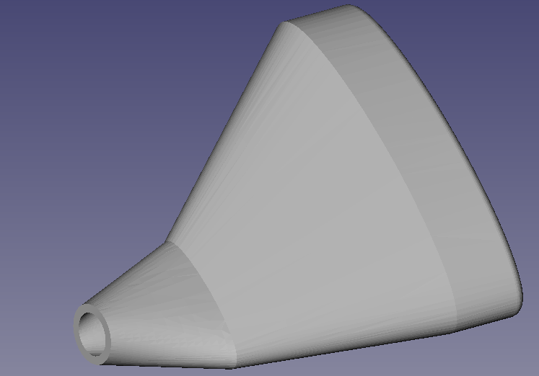

Figure 4: Granular jamming pad design

## Performance Testing

The first iteration of the complete hand was a moderate success. Most parts of the hand worked successfully, though some aspects need to be modified in the future.

The redesigned fingers were all individually successful. The new cable guides increased range of motion, printed successfully, and worked exactly as expected, such that pulling on the cable produced full motion of the digit. The base knuckle, the joint between the finger and palm, also worked successfully. This is notable because prior to manufacture of the hand as a whole, the base joint had never been tested (only the top two joints were tested, with the base hinge printed without its mate). Additionally, all the fingers worked at all their different respective lengths. This is another element of the project that had not yet been tested, and has proven successful. The hand is also proportionate to a real, human hand.

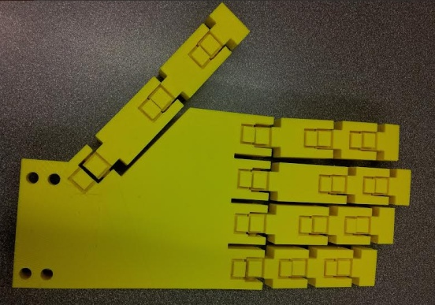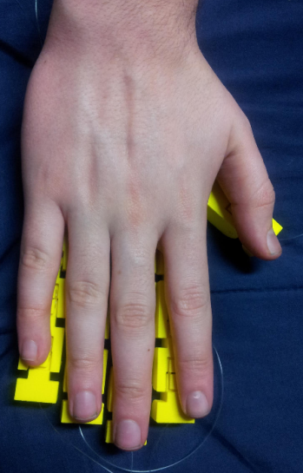

Figure 6: Hand model compared to a human hand.

The only major problem with the fingers was that the tolerance suggested by the TA was actually slightly too small. This caused the sides of the hinges interior to bridge to the inside of the exterior portion of the hinges. The same tolerance was also used for the revolute portions of the joints (between the joint pins and their housings), where it worked very well and completely eliminated rattling, as well as removing the necessity for bearings. The bridging between hinges was fairly easy to break via forcing the fingers through their range of motion, however there is a great deal of internal friction in the joints still, and looking inside them reveals some jagged, broken off webbing between the joint sections. Due to this friction, it also takes more tension than necessary to pull in the fingers. The solution to this is simply to slightly raise the tolerance for the next print iteration. Despite the fact that it had been set to an accepted value, 3D printing is very prone to changes in humidity, etc, and this larger tolerance will be used in the future.

The palm printed correctly except for one fairly large error. The cable guides for the palm actually hover above the palm surface, meaning that those cable guides not directly attached to palm walls actually broke off. Some inspection showed that this was a problem with the original model, however, and that it hadn’t been noticed because the gap was blocked by other features in OpenSCAD views. This problem has been immediately rectified for future designs. Printing the palm also made it clear that the wire guides only needed to be about half their original height, which is good news because it means that they can be made shorter in the next iteration, making more room for the granular jamming pad (allowing it to be “deeper” means that it will have greatly increased gripping ability). Aside from these two minor problems, the palm is complete.

The hand design does have one major issue, however. With the current orientation of the thumb, motion is actually almost exactly opposite to motion of a real, human thumb. This means that the angle of thumb attachment must be revisited (attaching it at the opposite angle would ensure realistic range of motion, but look very unlike a human hand when resting), and possibly a minor redesign must be performed for the thumb prior to Phase 5. However, this is the only major problem with the hand design, meaning that design is nearly complete and the bulk of focus can now be shifted to the forearm and granular jamming components.

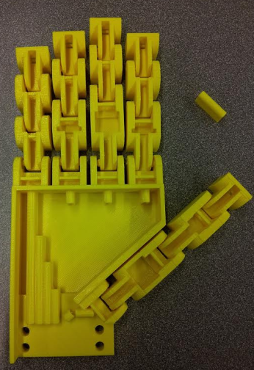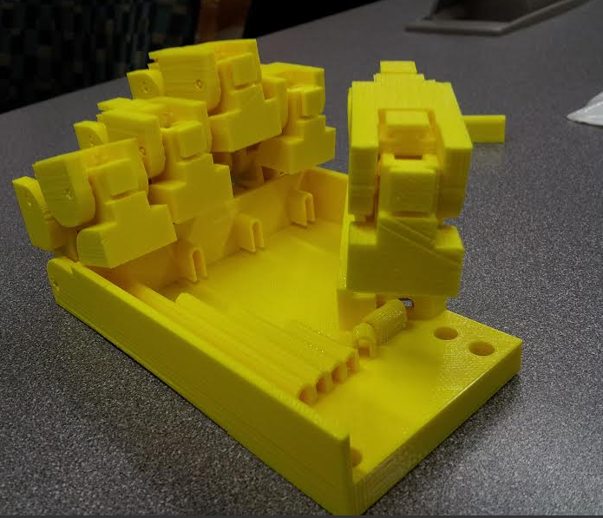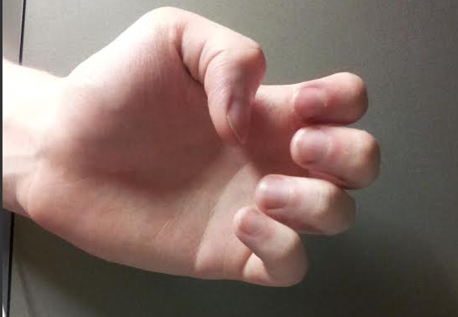

Figure 7: Printed hand (left), printed hand displaying range of motion (middle), and actual hand displaying range of motion (right). Notice the missing joint guides, and the recovered joint guide to the top right of the first photo. Note also how the finger motion is correct, but the thumb on the printed hand bends downward, toward the wrist, while the human hand bends upward, toward the fingers.

# Comments from Phase 3

WERE THERE ANY COMMENTS FROM PHASE 3 I DO NOT THINK THERE WERE

# Gantt Chart

SOMEONE NEEDS TO TAKE A SREENSHOT TO ADD IN HERE